TOWN HALL
MEETING

Thursday, Sept. 9, 2021
6 p.m. – 8 p.m.
Tom Green County Library
Sugg Community Room (Third floor)

OPEN TO PUBLIC

The City of San Angelo is considering expanding its Downtown District Overlay Zone to protect the historic and cultural character of downtown.

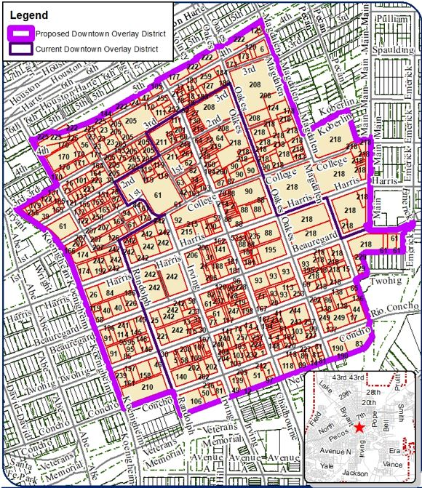

Properties within the Downtown Overlay District would be subject to an approval from the planning director or the Design and Historic Review Commission for exterior construction, including painting and signage. The public is invited to attend this town hall meeting for further information.

Please contact the Planning Division at 325-657-4210 or planning@cosatx.us for further information.

